The original training dataset looks as follows:

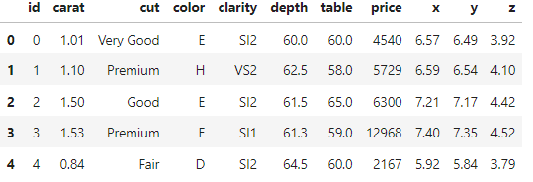

* We first convert the x, y and z variables which represent the length, width and depth of the diamond respectively into a single variable representing the volume of the variable.
$$volume=x ∙y ∙z$$

* The cut quality, color and clarity variables can each be converted to ordinal variables:

Cut: ranked from 0 (‘Fair’) to 4 (‘Ideal’)

Color: ranked from 0 (‘J’) to 6 (‘D’)

Clarity: ranked from 0 (‘I1’) to 7 (‘IF’)

The final training dataset looks as follows:

Using the price variable as our target variable, we can choose the remaining variables as explanatory variables in our predictive model. We use a LightGBM model to predict the price of diamonds.